COURSE: CLOUD AND NETWORK SECURITY _C1-2024

STUDENT NAME: LENNIE NTHIGA
STUDENT NO: cs-cns07-24170
SEPTEMBER 30,2024

WEEK 1 ASSIGNMENT 1
Assignment 1: TryHackMe: DNS In Detail

Contents
INTRODUCTION 3
DOMAIN NAME SEVER (DNS) 3
Domain Hierarchy 3
Top-level-Domain TLD 3
Second-Level Domain 3
Questions: 4
Record Types 4
A record 4
AAAA Record 4
CNAME Record 4
MX Record 4
TXT Record 5
Questions: 5
HOW DNS SERVER WORKS 5
Questions: 6
PRACTICAL 6
Questions: 6

INTRODUCTION
With the evolving world of information has brought about the development of broadening different industrial fields such as news, entertainment, commerce education and so on. All recent vendors of this providing an access to their products and services in the internet using websites. Thats where the Domain name server assist the user to remember and navigate to the desired vendor from the sending a website address to the process undertake in finding its Ip address and some sectors of the security of the website.

DOMAIN NAME SEVER (DNS)
DNS Domain Name system is a system that translates domains to their Ip address so that browsers can load resources.
Types:
- Authoritative DNS/Name Server- provides an update mechanism is responsible for storing the DNS records for a particular domain name and where any updates to your domain name DNS records would be made thus answers to DNS queries and translating domain names into IP
- Recursive DNS /Resolver - Clients typically do not make queries directly to authoritative DNS services. A recursive DNS service is usually provided by isp doesn’t own any DNS records but acts like an intermediary who can get the DNS information on your behalf. If a recursive DNS has the DNS reference stored for a period of time, then it answers the DNS query by providing the IP information. If not, it passes the query to one or more authoritative DNS servers to find the information.
Below is an DNS enumeration of tesla.com in kali
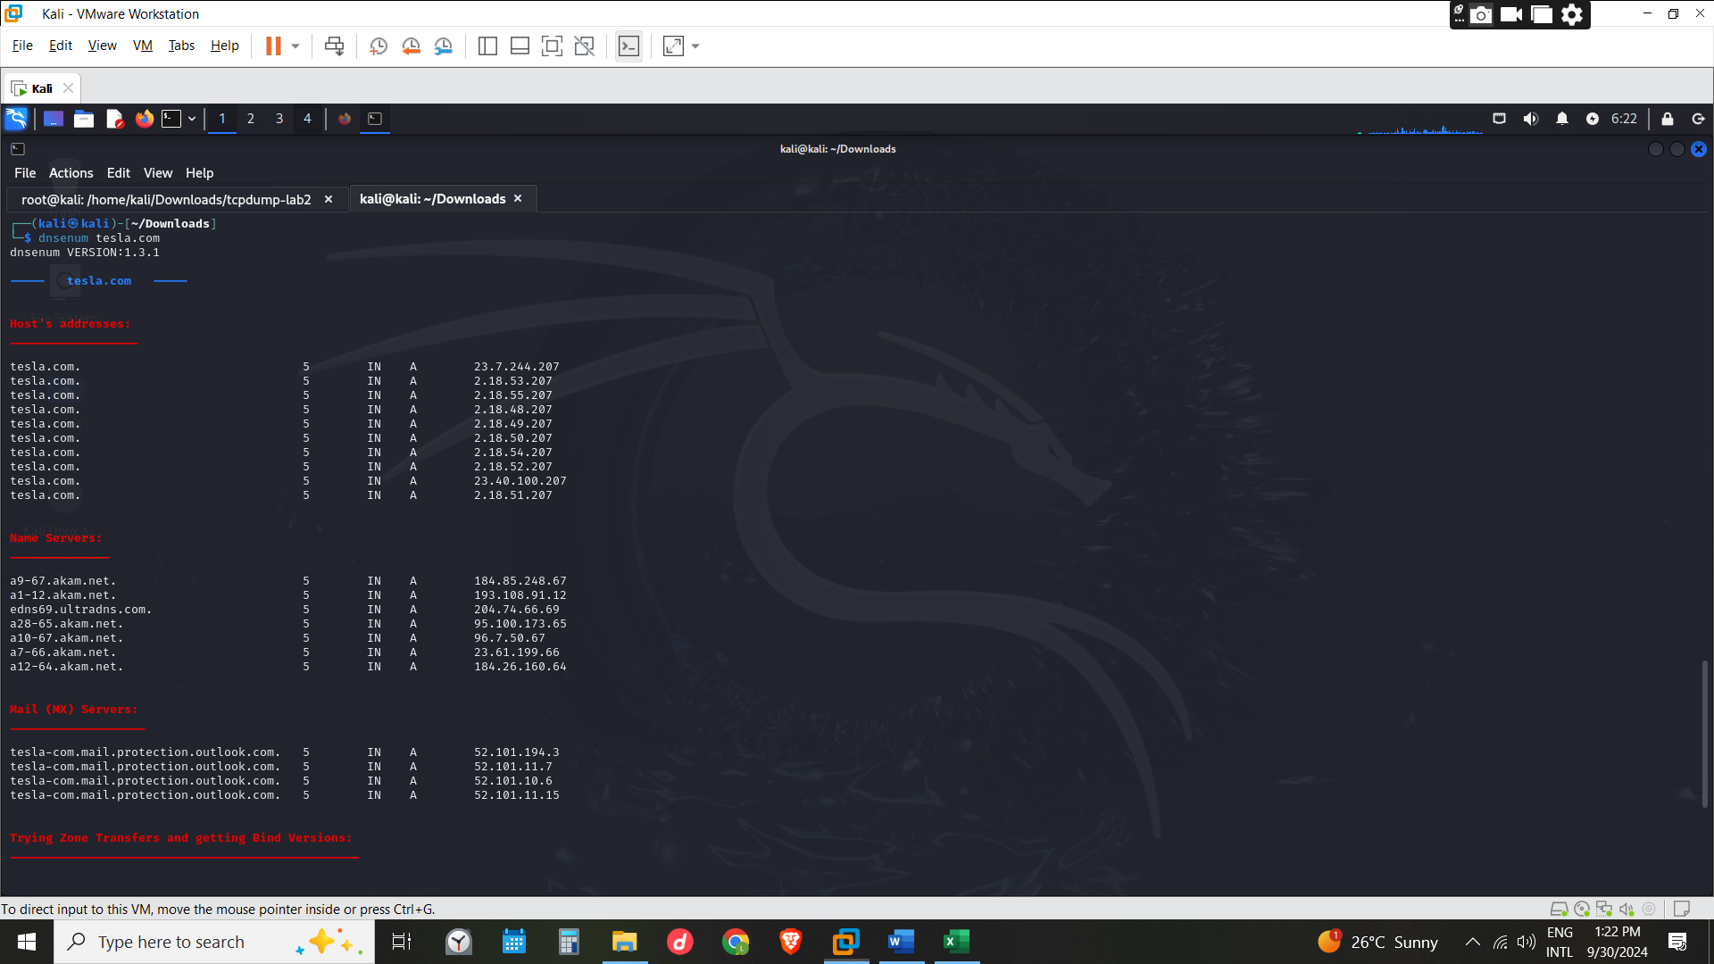

Domain Hierarchy

Top-level-Domain TLD
It’s the most right-hand part of a domain name e.g. tryhacme.com TLD would be .com
Types of TLD are
- gTLD (generic top-level domain) – meant to tell the domain name’s purpose e.g. tesla.org, mit.edu, socialsecurity.gov whereby .org is organization .gov is government and .edu is education. Theres’s addition of the gTLDs due to the emergence of different field leading to existence of gTLD such as. club, .biz etc
- ccTLD (country code top level domain) – meant to tell the location of the website .ca meaning (Canada) .uk (United Kingdom). Ke (Kenya)

Second-Level Domain
This is the name that is uniquely remembered by users e.g. “amazon” in amazon.com that is the name in the left side
When registering a domain name, the second-level domain is limited to 63 characters + the TLD and can only use a-z 0-9 and hyphens (cannot start or end with hyphens or have consecutive hyphens)
Subdomain
It’s a n extension of the second level domain that comes before it e.g. “post “in post.amazon.com.
This highlights the specific area/service of the domain. It can only use a-z 0-9 and hyphens (cannot start or end with hyphens or have consecutive hyphens) being limited to 63 characters. Maximum length of a domain is 253.

Questions:
- What is the maximum length of a subdomain? 63
- Which of the following characters cannot be used in a subdomain (3 b _ -)? _
- What is the maximum length of a domain name? 253
- What type of TLD is.co.uk? ccTLD
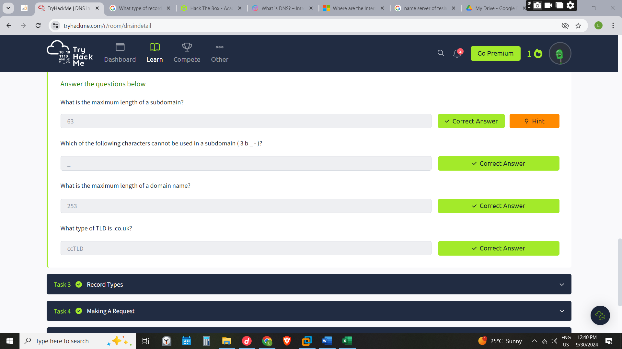

Record Types
A record – they resolve ipv4 addresses
AAAA Record - they resolve ipv6 addresses
CNAME Record - is a type of DNS record that maps an alias name to a true or canonical domain name E.g. TryHackMe's online shop has the subdomain name store.tryhackme.com which returns a CNAME record shops.shopify.com
MX Record - resolve to the address of the servers that handle the email for the domain you are querying. With purpose of ensuring the smooth delivery of emails by providing a reliable and efficient mechanism for routing messages can look like e.g. alt1.aspmx.l.google.com.
When an email is sent, the sender’s MTA initiates a DNS query to identify the recipient’s mail servers by looking up the appropriate MX records.
This query is directed to the recipient’s DNS server, which responds with the necessary MX records. The sender’s MTA establishes an SMTP connection with the recipient’s mail servers, beginning with the one with the higher priority, and moves down the priority list if needed until the email is successfully delivered.

TXT Record
Is a type of Domain Name System (DNS) record in text format, which contain information about your domain. Its where an administrator can enter text in the DNS in readable format.
TXT records are a key component of several different email authentication methods that help an email server determine if a message is from a trusted source such as Domain Keys Identified Mail (DKIM), Sender Policy Framework (SPF), and Domain-based Message Authentication, Reporting & Conformance (DMARC). By configuring these records, domain operators can make it more difficult for spammers to and can track attempts to do so. Referred from https://www.cloudflare.com/learning/dns/dns-records/dns-txt-record/

Questions:
- What type of record would be used to advise where to send email? MX
- What type of record handles IPv6 addresses? AAAA

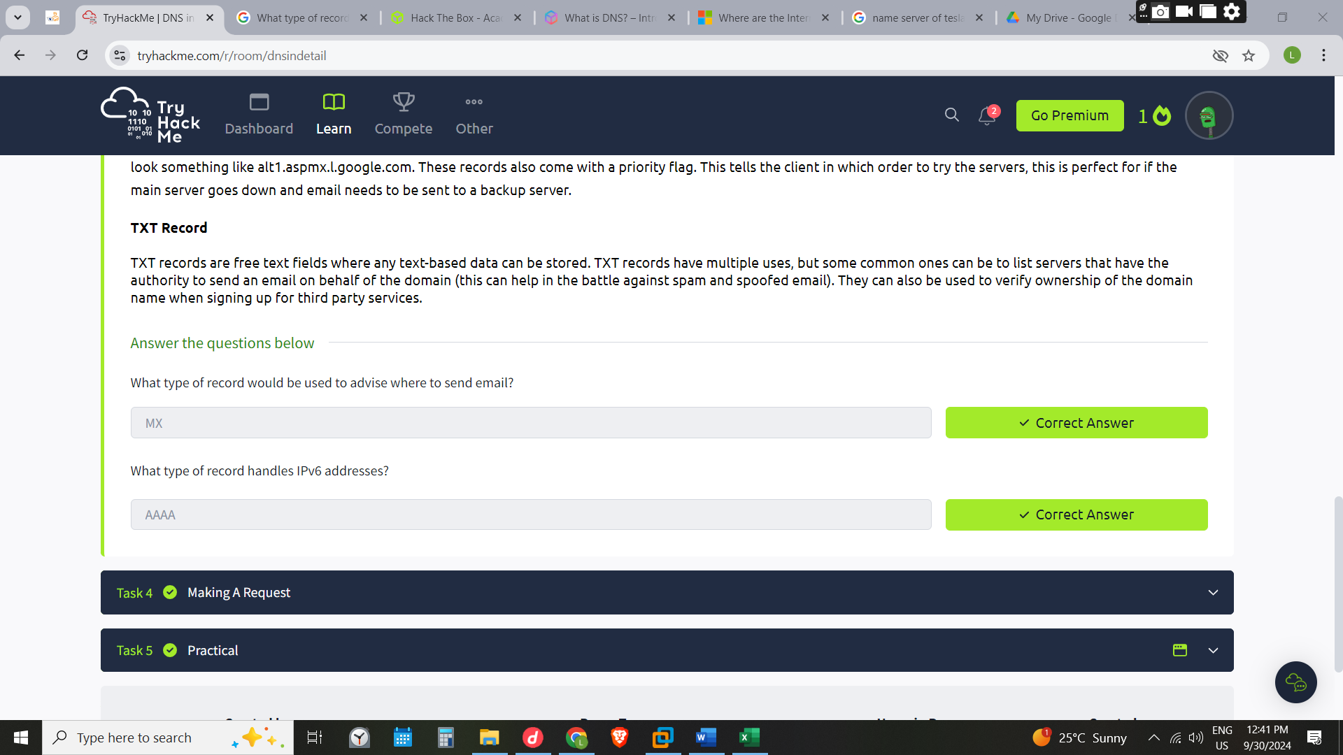

HOW DNS SERVER WORKS
- The users enter web address e.g. tesla.com in a browser the computer first checks its local cache to see if you've previously looked up the address recently; if not, a request to the Recursive DNS Server will be made.
- The recursive server also has a local cache of recently looked up domain names. If a result is found locally, this is sent back to your computer, and your request ends here. If the request cannot be found locally, a journey begins to find the correct answer, starting with the internet's root DNS servers.
- The root servers’ job is to redirect you to the correct Top-Level Domain Server in tesla .com the root server would redirect you the TLD server that deals with .com
- The TLD server holds records for where to find the authoritative server to answer the DNS request. E.g. the name serves of tesla.com is a7-66.akam.net. or a10-67.akam.net. can be very many
- Depending on the record type, the DNS record is then sent back to the Recursive DNS Server, where a local copy will be cached for future requests and then relayed back to the original client that made the request.
- DNS records all come with a TTL (Time to Live) value which is a number represented in seconds that the response should be saved for locally until you have to look it up again

Questions:
- What field specifies how long a DNS record should be cached for? TTL
- What type of DNS Server is usually provided by your ISP? recursive
- What type of server holds all the records for a domain? Authoritative
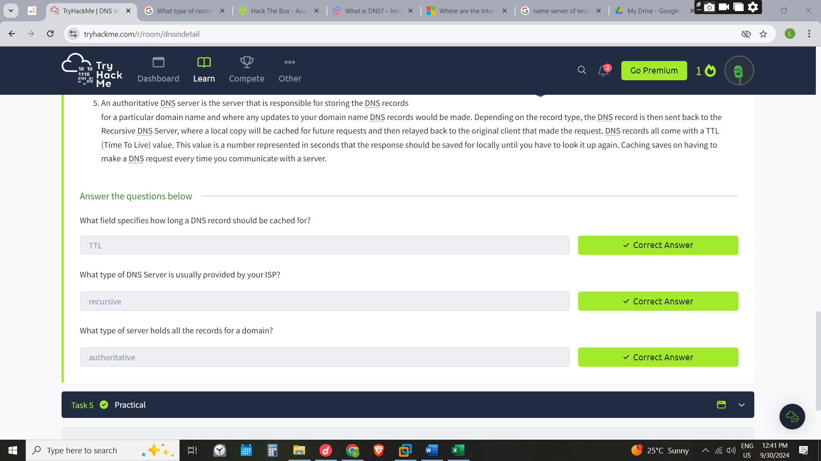

PRACTICAL

Questions:
- What is the CNAME of shop.website.thm? shops.myshopify.com
- What is the value of the TXT record of website.thm? THM{7012BBA60997F35A9516C2E16D2944FF}
- What is the numerical priority value for the MX record? 30
- What is the IP address for the A record of www.website.thm? 10.10.10.10
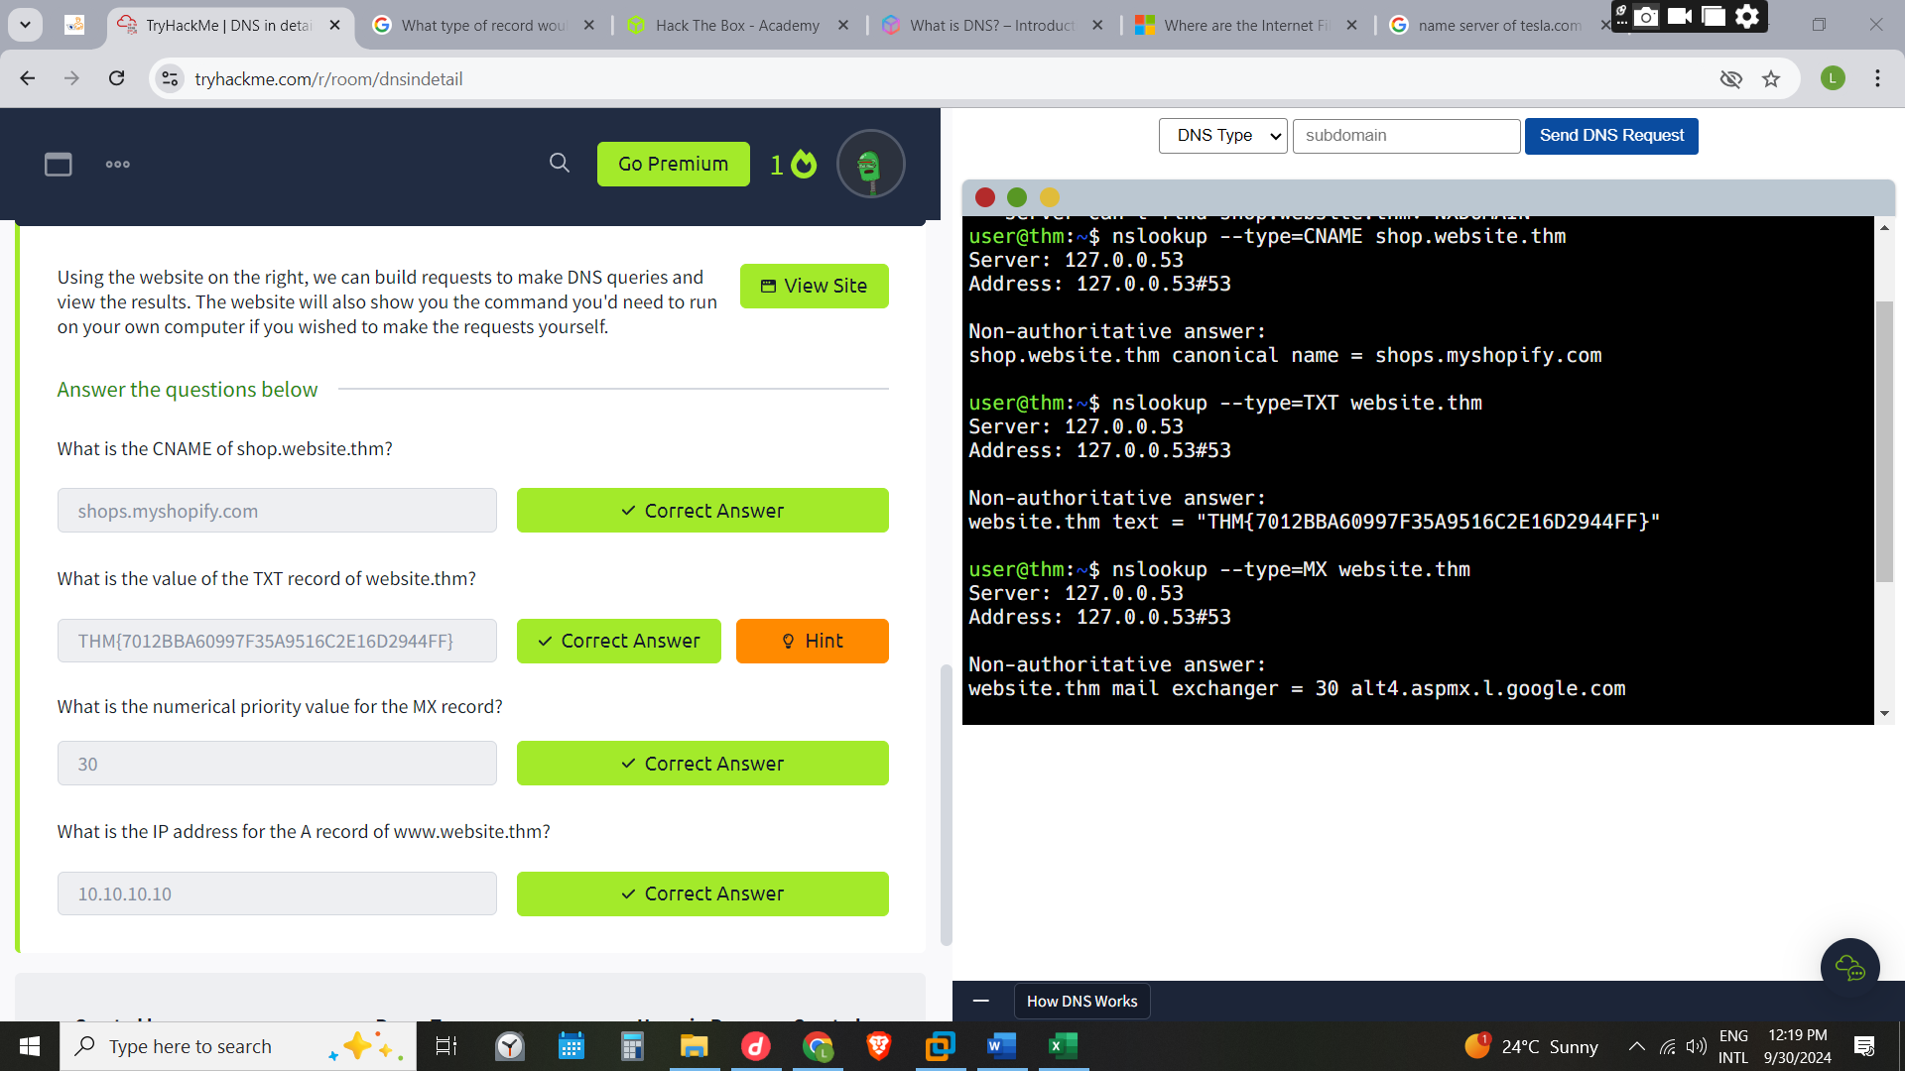

CONCLUSION
Dns can be one o the critical sector of an organization if vulnerable can be malicious to the organization and the organizations clients in the cases of dns With such attacks that can be costly some actions such as introducing repose policies and data authentications can be used to combat such spoofing dns tunnelling and other attacks .From this module it has demonstrated how the web address is located and the structure of the dns is .For the dns attacks and others reference @ https://www.fortinet.com/resources/cyberglossary/dns-security#:~:text=DNS%20security%20pinpoints%20the%20staging,they%20may%20try%20to%20send.
And https://www.ibm.com/topics/dnssec

Module completion link: www.tryhackme.com/r/room/dnsindetail?utm_campaign=social_share&utm_medium=social&utm_source=twitter
